**CLASSROOM TO CAREER ━ REFLECTION ON AN INDUSTRIAL TALK**

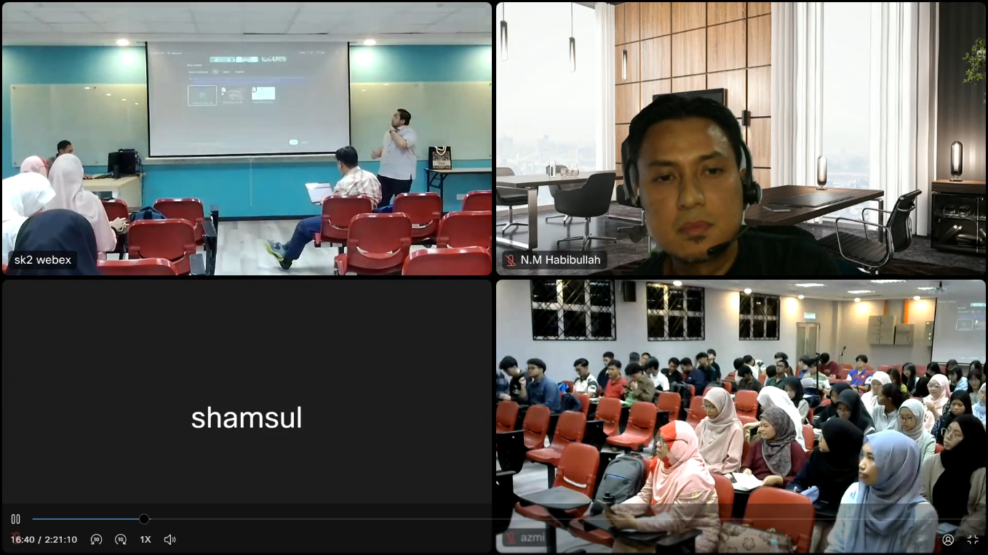

TABLE OF CONTENTS:

1. Description of Speakers Experience 2
2. Basic Skills Required for Computer Science 2
3. Skills Required by Industry2
4. Reflection 3
5. References 3

GROUP MEMBERS:

1. Chew Jie Sheng (A24CS0059)
2. Evelyn Ang (A24CS0068)
3. Lee Pei Yuan (A24CS0262)
4. Niveethita A/P Pandia Rajan (A24CS0148)

**Description of Speakers Experience**

Mr. Mohd Hakimi Iqmall, an experienced professional as a system analyst and project manager, emphasized the importance of strong programming fundamentals for adapting to new technologies like Go language. In 2018, he joined Okakishi Sdn. Bhd as a game programmer, where troubleshooting a system failure caused by his code push, improving his adaptability and problem-solving skills. From 2019 to 2021, he conrtibuted to RADIS 4.0 and ICESys at UTM Research Computing. Since 2021, he has been a system analyst at UTMDigital and working on projects such as Sistem Saraan Perkhidmatan Awam (SSPA) for UTM staff.

Mr. Nik Mohd Habibullah, a UTM alumnus and entrepreneur, began his with creating a montage for UTM’s Digital Library and an internship at the library. He later founded Micro-Semiconductor Sdn. Bhd, focusing on hardware development. Among his notable products is Get Me Hired, a career development platform for fresh graduates and Dialysis Manager, an integrated system designed especially to improve the quality of services of haemodialysis centers. These projects demonstrate how technical expertise and entrepreneurial vision can work together to have a significant influence in a variety of industries.

[3] [4]

Career Background of the Speakers

Basic Skills Required for Computer Science

Technical skills are essential for computer science student as their basic knowledge and career prospects in this field. First, programming languages are crucial in computer science because student need to learn how to utilise programming language to develop software and system in their future. For example, C++ is one of the programming languages. Next, Version control is the practice of tracking and managing changes to software code . Version control systems are essential tools for tracking and managing changes to codebases over time. Student can learn how to collaborate with teammate and merge other code. (Smith, J.,2020) Furthermore, student needs to learn about data structure because It is foundation for managing and organizing data efficiently for computer science. Student also need understood the logic behind algorithm because it is essential for solving computational problems so student can design system that store and manipulate data effectively. Besides, analytical skills enable students to identify the problem when developing software or managing data, and logical skills can help to enhance the problem-solving skills when solving the problem. Students with good logical skills can also design efficient algorithms and the shortest program that performs tasks optimally. (Weiss, M.A., 2013) Lastly, framework in programming is a tool that provides ready-made components or solutions that are customized to speed up development. A framework can include support programs, compilers and APIs to develop software and create systems.

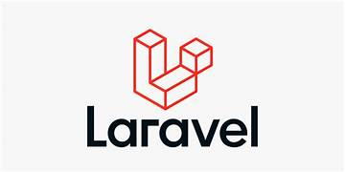[5] 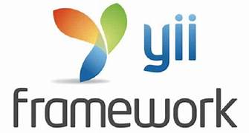 [6]

Examples of Framework

Skills Required by Industry

Success in the IT industry requires both technical expertise and strategic career planning. A strong foundation in programming, cybersecurity, and data analysis is essential, along with soft skills like problem-solving, communication, and adaptability. To maximize career opportunities, preparation plays a crucial role such as crafting a professional resume, obtaining relevant certifications, and showcasing skills through a well-documented portfolio. Researching job trends, company culture, and career growth potential ensures informed decision-making. The IRPA method further enhances career prospects by aligning personal strengths with industry demands, strategically applying through platforms like LinkedIn and Jobstreet, and continuously improving skills. By integrating technical proficiency with a structured career approach, professionals can secure long-term success in the IT field.

Reflection

Evelyn expressed that the talk emphasized the essential balance between technical expertise and management skills required for success in the IT field. The real-life experiences shared by Mr. Hakimi illustrated how academic knowledge aligns with industry demands. She intends to strengthen her technical proficiency while also enhancing her soft skills, particularly in communication and teamwork, over the next four years.

Peiyuan reflected on Mr. Hakimi’s extensive work experiences and emphasized the importance of both technical and management skills for computer science students entering the industry. The speaker also encouraged students to develop their soft skills, such as communication and leadership, by participating in workshops and events during their degree. Peiyuan gained valuable insights and knowledge from the talk, which he found highly beneficial.

From the talk, Jason shared that during the industry talk, Mr. Hakimi provided valuable insights into the significance of both technical and soft skills for computer science students. The speaker emphasized the importance of developing communication and leadership skills through participation in workshops and events. Inspired by the talk, Jason is motivated to strengthen his technical expertise while also enhancing his interpersonal skills to prepare for a successful career in the field.

Niveethita is inspired by the valuable insights and essential information on building a career in computer science from the talk. She found it fascinating to learn about two different career paths within the same field. This experience inspired her to enhance her technical skills by engaging in self-directed learning beyond the classroom and participating in university activities to develop her soft skills. She also plans to conduct background research on technology market trends to ensure continuous skill development over time.

**References**

1. Weiss, M. A. (2013). Data structures and algorithm analysis in C++ (4th ed.). Pearson Education.
2. Smith, J. (2020). Introduction to version control systems.
3. <https://digital.utm.my/>
4. <https://microsemi.com.my/>
5. <https://www.freelancinggig.com/blog/2018/03/02/use-yii-framework/>
6. <https://www.northlink.digital/services/php-laravel>